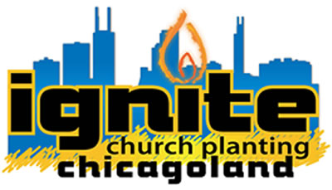

NEW CHURCH PLANTER APPLICATION

Application – STEP 1: IGNITE CHURCH PLANTING

Please fill out the form below and email it to: [lance@ignitechurchplanting.com](mailto:lance@ignitechurchplanting.com) along with a resume.

NEW CHURCH PLANTER APPLICATION

Name:

Email:           

Address:

City:

State:

Zip:

Best Phone Number:

Spouse (if married):

Children (names, age):

How long have you been a Christian?

CHURCH PLANTING QUESTIONS:

Why do you desire to start a new church in the Chicagoland area?

What has been your interest / involvement in new church planting to date?

What are your long-range goals / plans?

MINISTRY EXPERIENCES:

**Please answer these questions based on your ministry, business or personal experience.**

Do you meet the requirements of an elder as outlined in 1 Timothy 3:1-7?

Please answer YES or NO – if NO, Please explain:

Yes  No

Explain:

Describe a situation in which you planned, organized and launched a new group. Please give some details:

Describe an experience where you helped coach or supervise an individual through a problem-solving situation. Detail the steps you followed.

Describe a long-term planning effort that successfully reached your goals.

How do you maintain regularity and consistency in your prayer and devotion life?

List your spiritual gifts and describe how you have utilized those gifts in ministry.

What are your personal goals in the next 5 years?

PERSONAL QUESTIONS:

What are your favorite hobbies and pastimes?

What types of behavior in others do you especially like or admire?

What are some of your pet peeves in the behavior of others?

Describe the type of people you most enjoy being with (e.g. urban, rural, corporate, “yuppies”, sports-minded, blue collar, white collar, etc.),

In what types of areas would you prefer to live (e.g. urban, suburban, etc.)?

Describe some of your key personality strengths.

Describe some of your personality weaknesses.

What activities or issues really motivate you?

What are some of your strongest theological convictions? (What really burns in your heart?)

Detail your philosophy of ministry.

In what areas of ministry do you need the most development?

Describe an activity you accepted because of the integrity of the principle rather than your admiration for the activity.

Describe your experience in developing leadership within a church or business situation.

Describe one of the difficult pastoral care needs you have faced. How did you handle the situation?

Describe a time when you sensed there was a need in your church. What did you do to insure that need was met?

Give an example of a time the Lord directed you in ministry. How did you communicate the vision to others so that they worked together with you to accomplish the task?

**THANKS FOR YOUR INTEREST IN CHURCH PLANTING WITH IGNITE CHURCH PLANTING. AFTER COMPLETING THIS FORM:**

1. EMAIL TO: [lance@ignitechurchplanting.com](mailto:lance@ignitechurchplanting.com) .
2. PLEASE ATTACH YOUR RESUME.
3. FILL OUT STEP 2: BIOGRAPHICAL SKETCH @ <http://ignitechurchplanting.com/start.html>